CS 255 Project Two – DriverPass System Design Document

UML Diagrams

Leslie Sawyer
Southern New Hampshire University
CS 255 – System Analysis and Design
October 16, 2026
UML Use Case Diagram

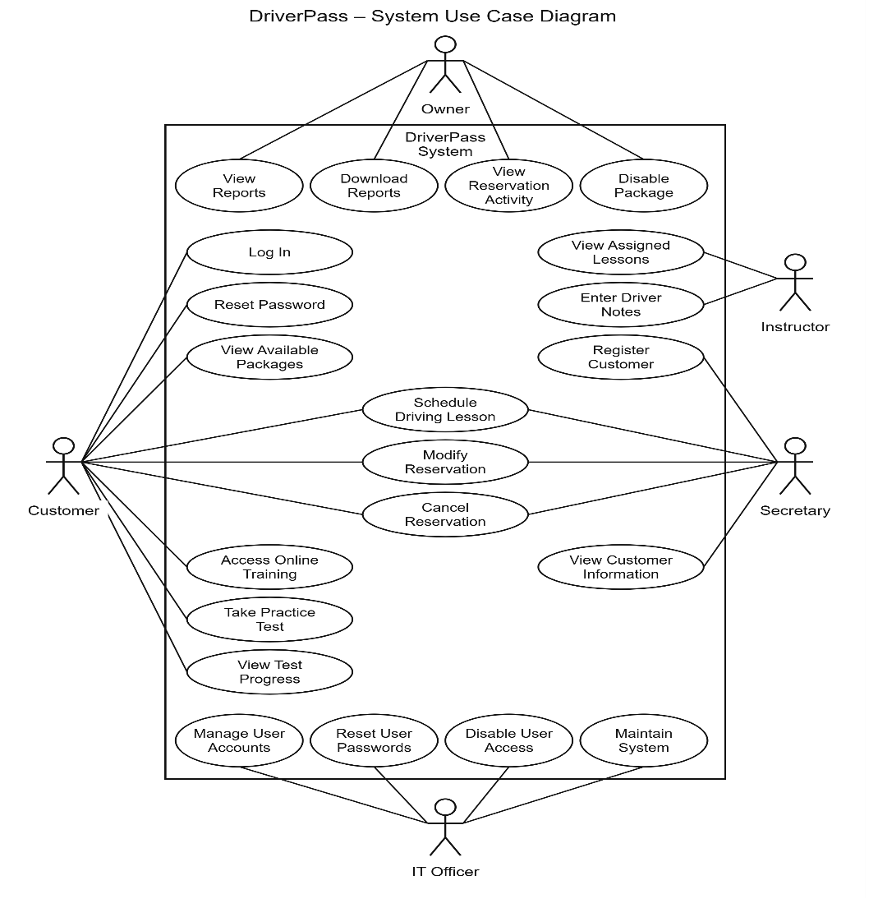

UML Activity Diagrams

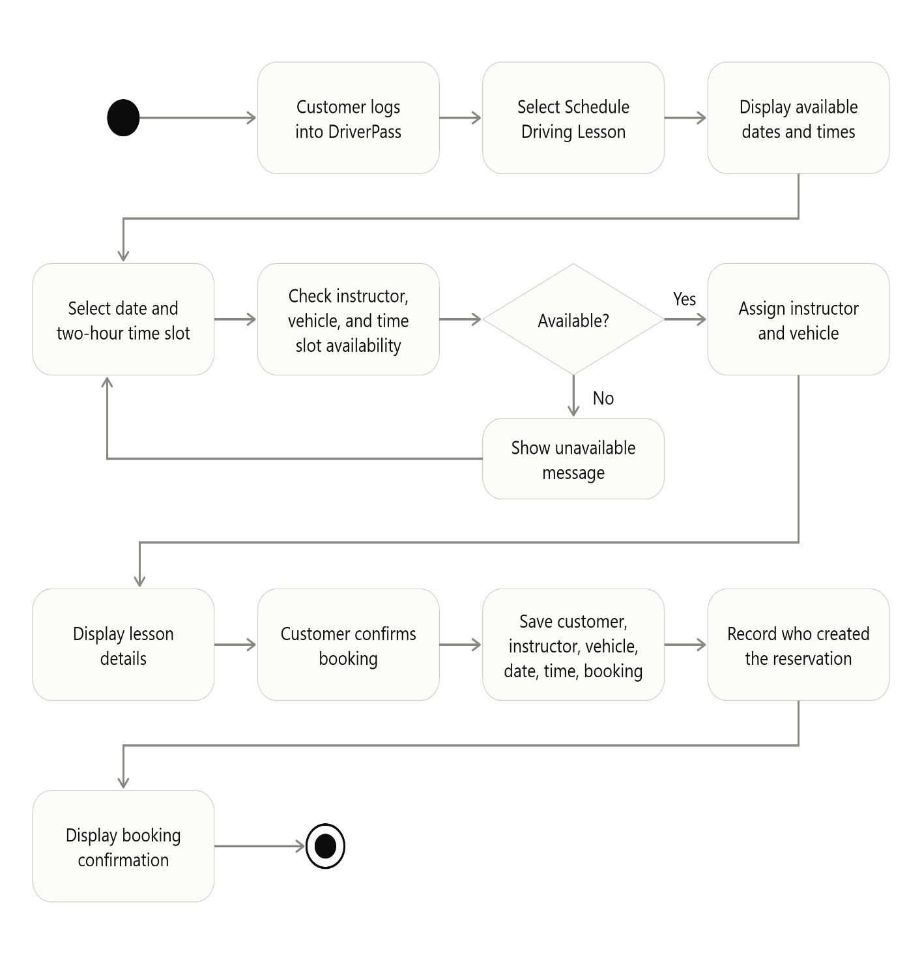
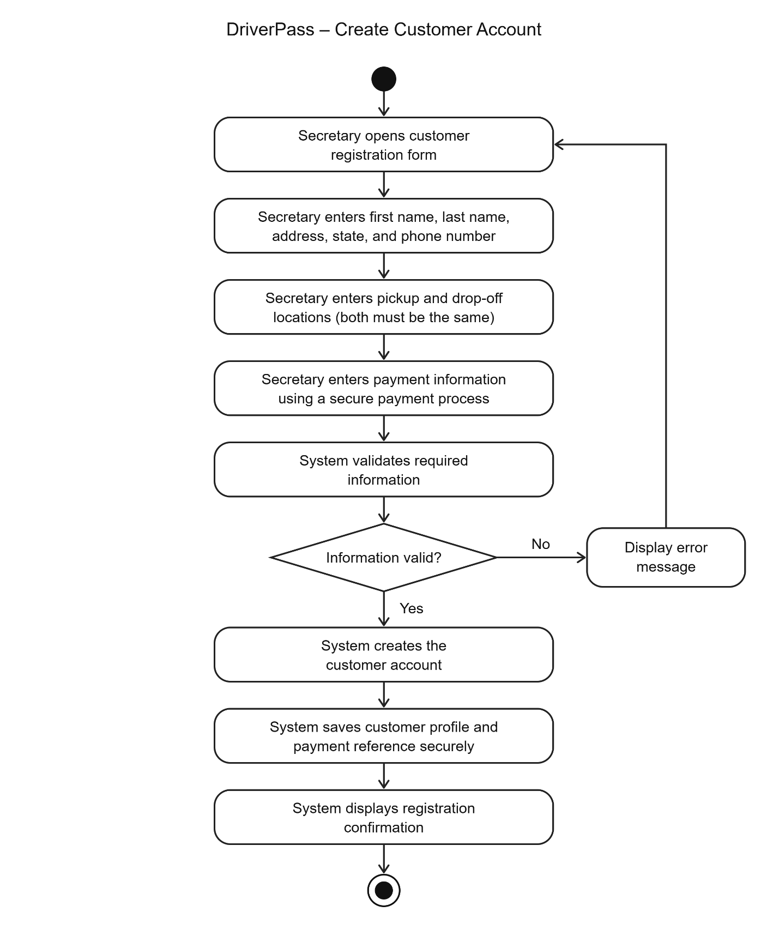

UML Sequence Diagram

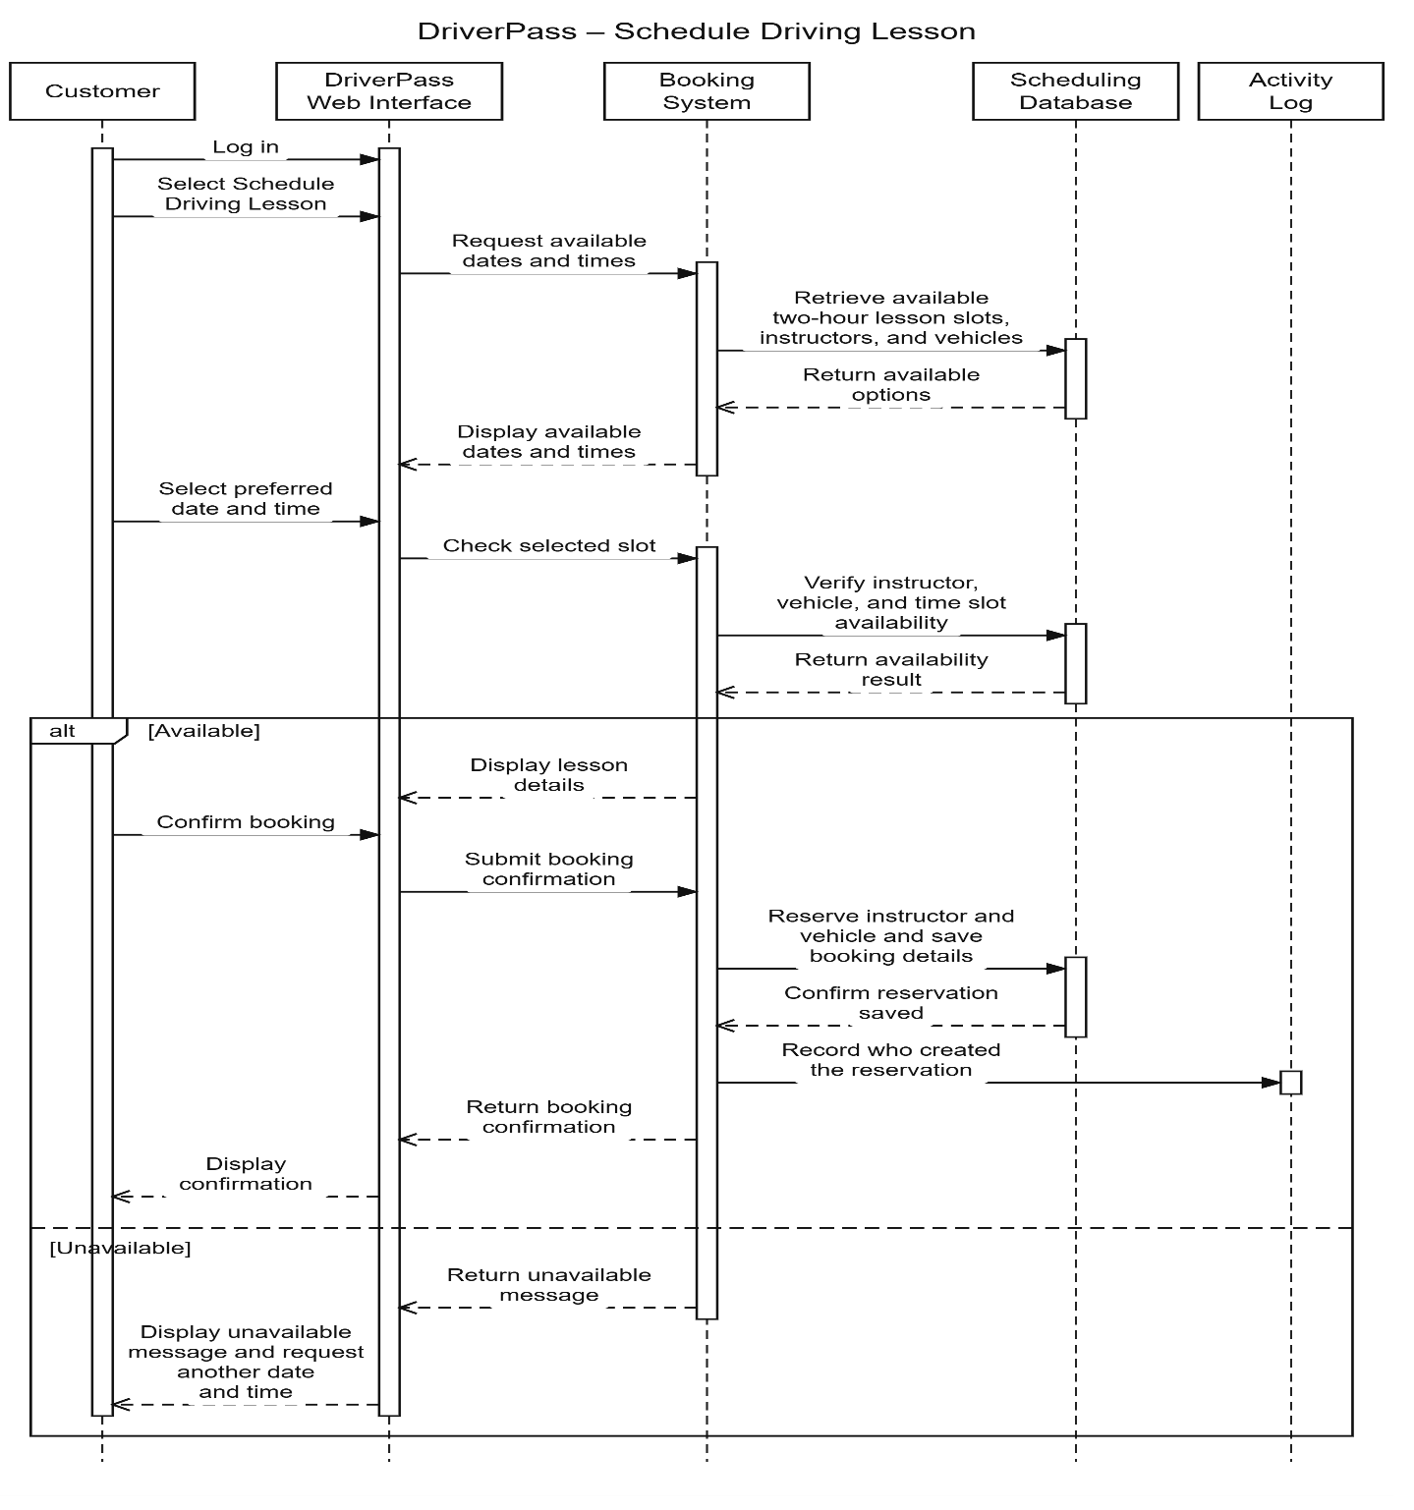

UML Class Diagram

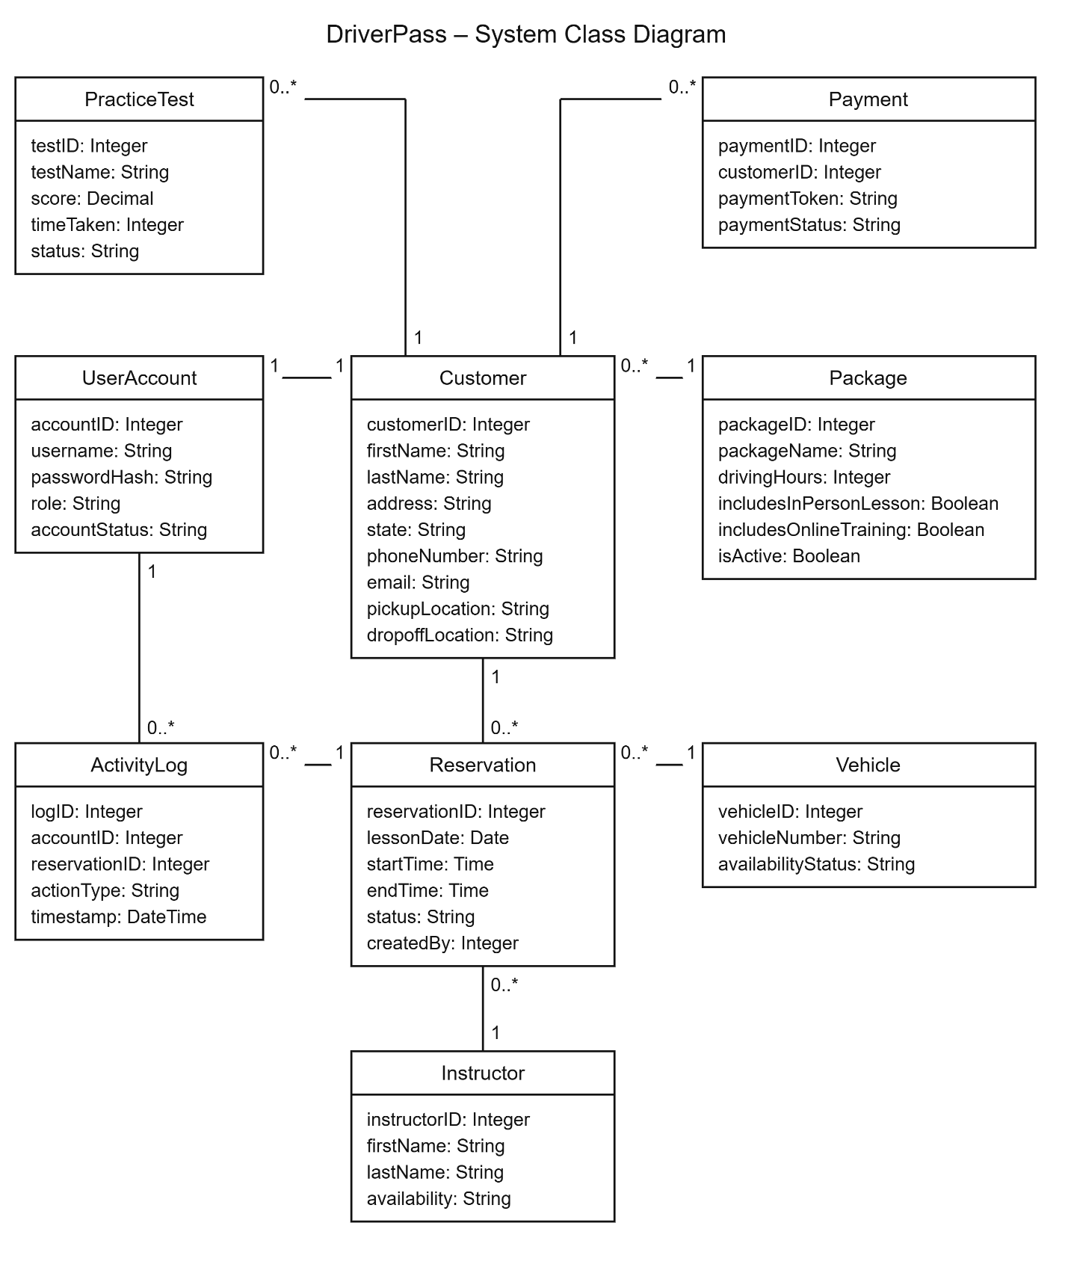

Technical Requirements

DriverPass will need a cloud-based system that customers and employees can access through a web browser. Customers should be able to create accounts, schedule driving lessons, manage reservations, and access online training based on their package.
Hardware: Customers and employees will need a computer, tablet, or smartphone with an internet connection. DriverPass will also need computers for office employees to manage customer information, reservations, and reports.
Software: The system will need a web application, a database to store customer and reservation information, and a secure login system. It should also support online practice tests, scheduling, and different access levels for employees.
Tools: Lucidchart can be used to design the UML diagrams. The development team will also need programming tools, database management tools, and testing tools to build and maintain the system.
Infrastructure: DriverPass should use cloud hosting so users can access the system from different locations. The system will need secure connections, regular backups, and access controls to protect customer information. It should also keep track of reservation changes and support updates to DMV training materials.
These requirements will help DriverPass manage its daily operations while keeping the system accessible, organized, and secure.

